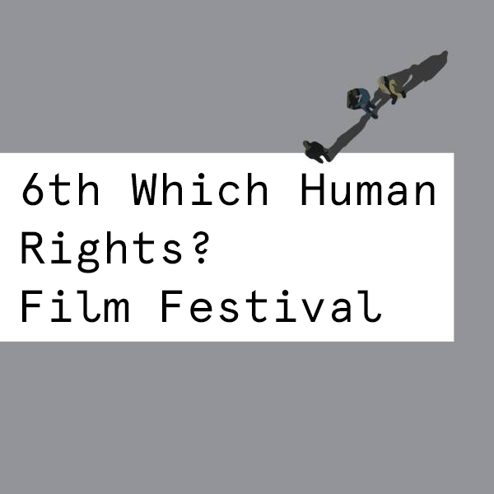

Press Release

THE 6th WHICH HUMAN RIGHTS? FILM FESTIVAL
Workers and Refugees are Under the Spotlight

Which Human Rights? Film Festival celebrates its 6th edition between 13-17 December with film screenings, workshops and panels. The themes of the year are ‘workers’ and ‘refugees’ while Gezi Park revolts, Ukraine, ecological issues are also play parts in the program.

The 6th Which Human Rights? Film Festival organized by Documentarist in Istanbul will be held between December 13-17, 2014. The main themes of the festival that focuses on specific themes every year were determined as 'workers' and 'refugees' (displaced people). There will be a special part in the festival program for documentaries on Gezi Park revolts as well.

In the festival where many films about workers, especially the miners will be screened, there will be previews for "Comradeship" (Kameradschaft) by Georg Wilhelm Pabst dated 1931 and "Karanlıkta Uyananlar" (Those Awakening in the Dark) (1964) by Ertem Göreç. The program also includes a series of documentaries made about the lives and working conditions of the workers in Turkey.

The theme of 'being displaced' which is one of the most problematic cases of our age is also being addressed in the festival with a series of films and a panel. The films in this part focuses on the stories of people who fled their countries because of wars, poverty or political views, especially Syrians and Palestinians. Also a round table meeting will be held with the participation of refugees from these countries within the 6th Which Human Rights? Film Festival under the title of Displaced People of Our Time: Palestinians and Syrians.

Gezi Resistance selection which was included last year in the festival is continuing this year with new films. In addition to a number of new documentaries in the selection, the film by Reyan Tuvi called "Yeryüzü Aşkın Yüzü Oluncaya Dek…" (Love Will Change the Earth) which was excluded from Golden Orange Film Festival program, an act that caused many reactions, will meet the audience one more time. A package of short films from Ukraine will also presented while documentaries on ecological life takes part in the program as usual.

Video-Activism Workshop which is one of the regular events of Which Human Rights? Film Festival will be held with a new content and the film examples made with video-activism style will be screened under the title of 'Testimonies'.

Additionally, there will be a workshop with the theme of Alternative Urban Futures and a seminar with the title Recovery of Common Areas.

Workshops with Children which is again one of the traditional events of the festival and was organized in various cities during the year will continue. Right after the festival, a group of the festival volunteers will travel to Urfa and Soma in order to make video and art workshops with Syrian kids and the children from families of miners.

6th Which Human Rights? Film Festival which will be realized at SALT Beyoğlu, Aynalıgeçit Etkinlik Mekânı, Tütün Deposu and SALT Galata. All the events are free of charge.

More info: www.hihff.org
press@documentarist.org
Tel: 0 (212) 252 49 24

